MongoDB Basic Practice Task
CRUD Operations, Query Operators & Real-World Library System

Objective

The objective of this practice task is to understand the basics of MongoDB, create databases and collections, perform CRUD operations, use query operators, and apply MongoDB concepts to a real-world use case.

Database & Collection Setup

Use studentDB
db.createCollection("students") show collections

The studentDB database and students collection are created for storing student information.

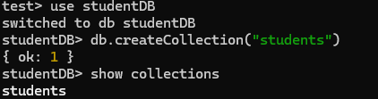

Insert Operations

Insert one document:

db.students.insertOne({ name: "Ajay", age: 21, course: "MERN Stack", status: "ongoing" })

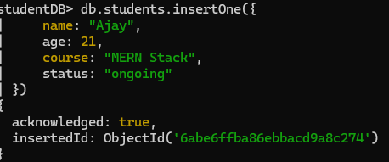

Insert multiple documents:

db.students.insertMany([ { name: "Arun", age: 22, course: "MERN Stack", status: "completed" },
{ name: "Karthik", age: 20, course: "Java Full Stack", status: "ongoing" },
{ name: "Priya", age: 21, course: "MERN Stack", status: "ongoing" },
{ name: "Divya", age: 23, course: "Python Full Stack", status: "completed" }
])

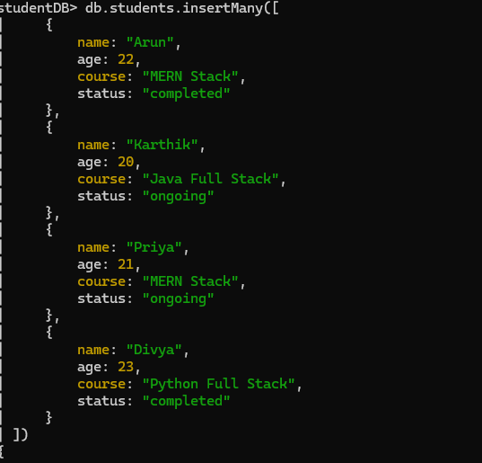

Read Operations

Fetch all documents:

db.students.find() db.students.find().pretty()

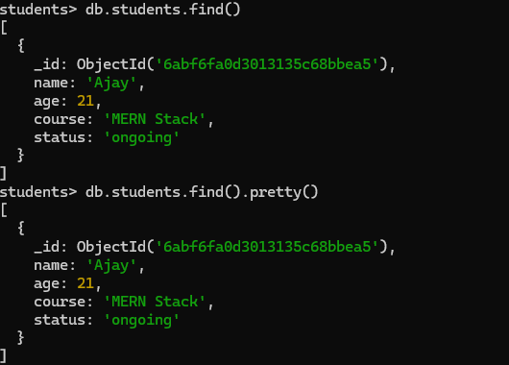

Fetch students enrolled in MERN Stack:

db.students.find({ course: "MERN Stack" })

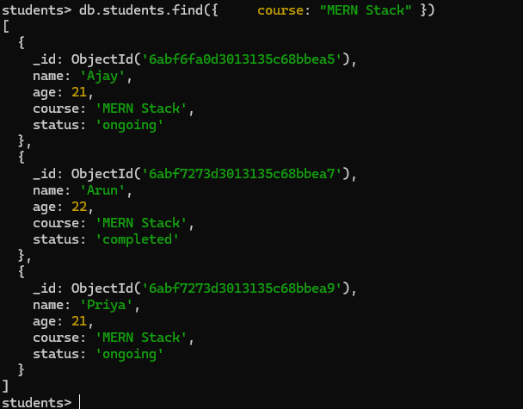

Update Operations

Update one student's status:

db.students.updateOne( { name: "Ajay" },
{ $set: { status: "completed" } }
)

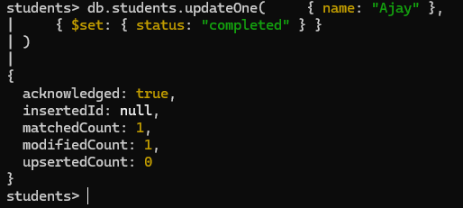

Update multiple students:

db.students.updateMany( { course: "MERN Stack" },
{ $set: { status: "completed" } }
)

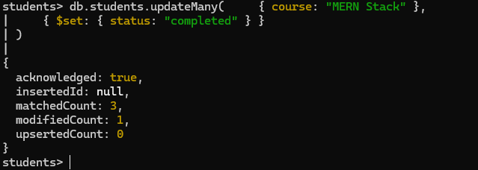

Delete Operations

Delete one document:

db.students.deleteOne({ name: "Karthik" })

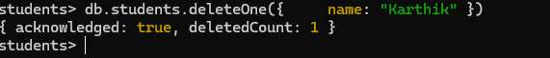

Delete all documents for practice only:

db.students.deleteMany({})

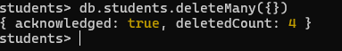

Query Operators

Operator | Purpose | Example
$gt | Find students older than 21. | db.students.find({ age: { $gt: 21 } })
$lt | Find students younger than 22. | db.students.find({ age: { $lt: 22 } })
$in | Find students in MERN Stack or Java Full Stack. | db.students.find({ course: { $in: ["MERN Stack", "Java Full Stack"] } })
$and | Find students older than 20 and completed. | db.students.find({ $and: [{ age: { $gt: 20 } }, { status: "completed" }] })
$or | Find students in MERN Stack or Python Full Stack. | db.students.find({ $or: [{ course: "MERN Stack" }, { course: "Python Full Stack" }] })
$exists | Find documents where email exists. | db.students.find({ email: { $exists: true } })
$ne | Find students whose age is not equal to 21 | db.students.find({ age: { $ne: 21 } })

Real-World Use Case — Library System

A Library System can use MongoDB to store books, authors, categories, prices, and availability. The following commands demonstrate inserting, searching, and updating library data.

Create database and collection:

use libraryDB
db.createCollection("books")

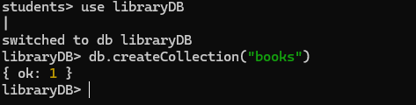

Insert books:

db.books.insertMany([ { title: "JavaScript Basics", author: "John Smith", category: "Programming", price: 450, available: true }, { title: "MongoDB Guide", author: "David Lee", category: "Database", price: 550, available: true }, { title: "React Fundamentals", author: "Robert James", category: "Programming", price: 600, available: false } ])

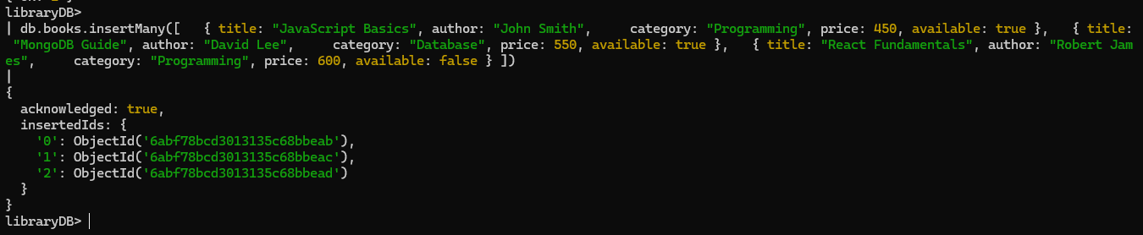

Search programming books:

db.books.find({ category: "Programming" })

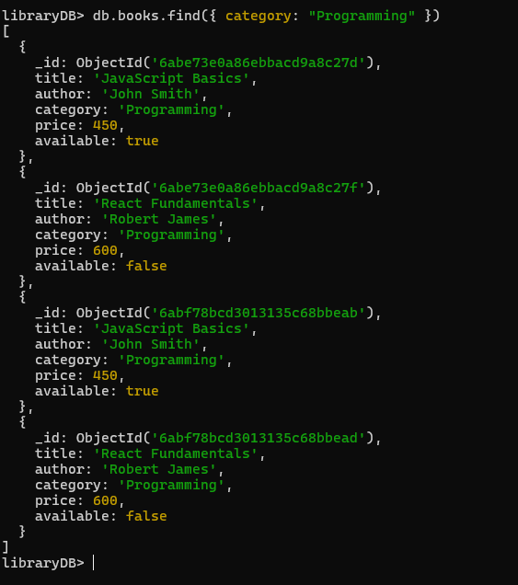

Search books costing more than ■500:

db.books.find({ price: { $gt: 500 } })

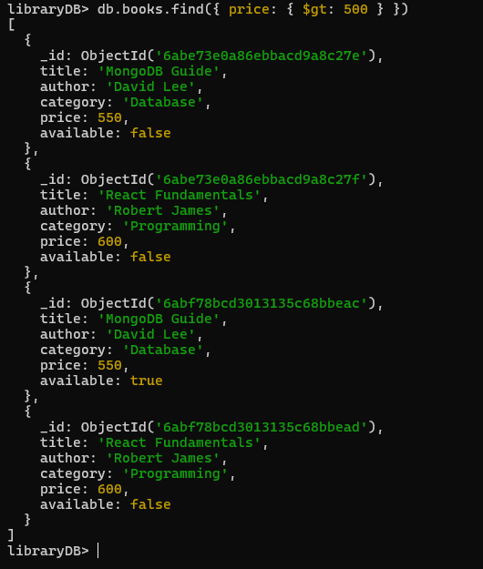

Update MongoDB Guide availability:

db.books.updateOne( { title: "MongoDB Guide" },
{ $set: { available: false } }
)

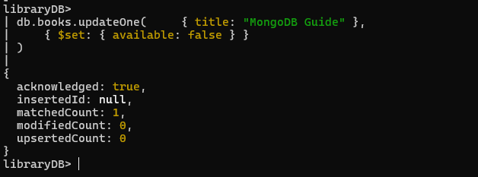

Sample MongoDB Practice Screenshot

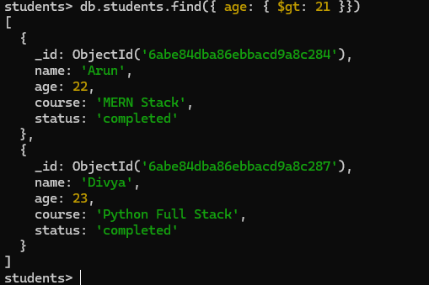

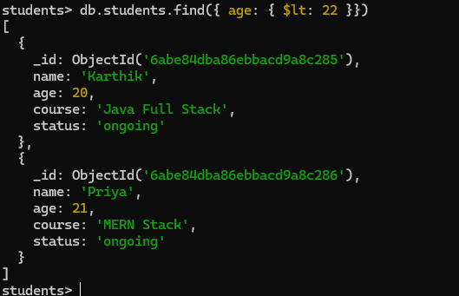
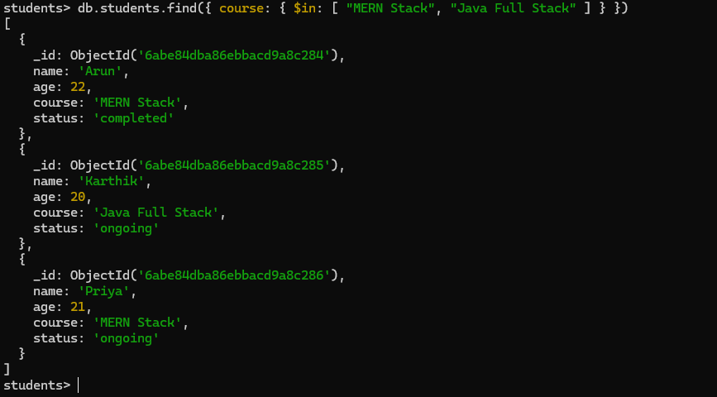

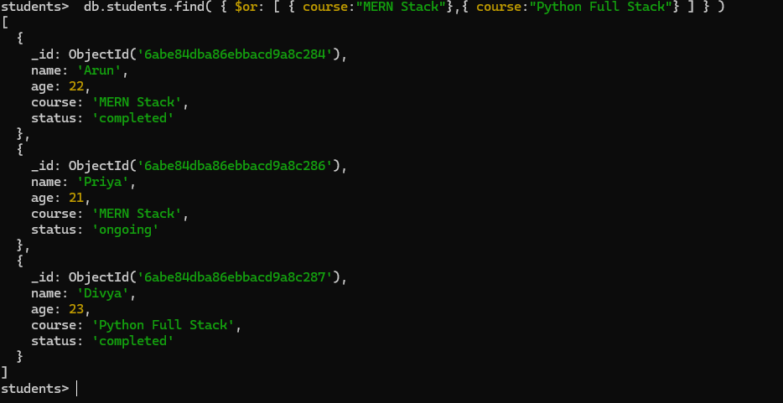

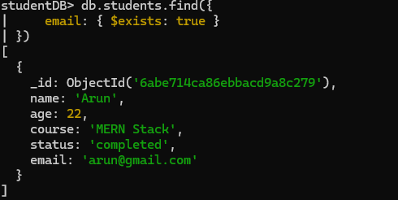

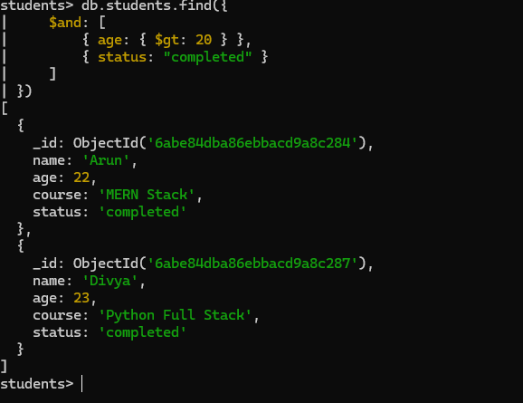

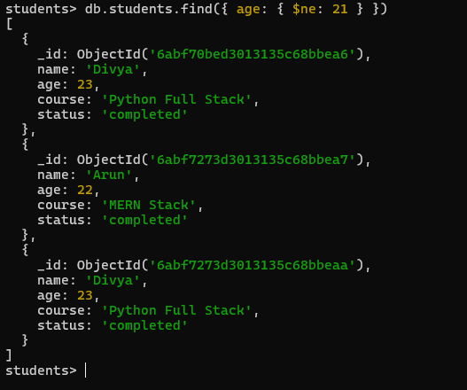

Conclusion

MongoDB is a NoSQL document database that stores data in flexible JSON-like documents. In this task, database and collection creation, insert, read, update, and delete operations were practiced. Query operators such as $gt, $lt, $in, $and, $or, and $exists were also used. The Library System demonstrates how MongoDB CRUD and search operations can be applied to a practical application.

